PERFORMANCE INNOVATIVE TASK (PIT) – FINALS
“CYBERCRIME AWARENESS”
I. Activity Objective
- Design an interactive social media platform using Figma that demonstrates how online posts can be reviewed for possible cyber libel while protecting users' freedom of expression.
II. General Instructions
- Form a group of 3–5 members.
- Select three (3) scenarios from the provided Scenario Bank.
- Analyze each scenario based on the concepts discussed in Cyber Libel Law.
- Using Figma, design a social media platform called CampusConnect.
- Create at least five (5) interactive screens that demonstrate how the platform handles online posts and potentially defamatory content.
- Connect the screens using Figma's prototyping features to make the interface clickable.
- Demonstrate how your platform handles the three selected scenarios.
- Present your prototype and explain your group's moderation decisions.

III. Required Figma Screens
Screen 1: Social Media Feed
- Display sample social media posts.
- Include Like, Comment, Share, and Report buttons.
- Provide a Create Post button.
Screen 2: Create a Post
- Allow users to write and preview posts.
- Include Publish and Cancel buttons.
- Demonstrate what happens when a user submits a post.
Screen 3: Content Warning
- Display a warning when a post contains a potentially defamatory statement.
- Explain why the content was flagged.
- Include Edit Post, Request Review, and Cancel buttons.
Screen 4: Content Moderation Dashboard
- Display reported or flagged posts.
- Show the reason for reporting.
- Allow a moderator to review posts and select an appropriate action.
Screen 5: Moderation Decision and Appeal
- Display whether a post is allowed, flagged for review, or removed under platform rules.
- Provide a brief explanation of the decision.
- Include an Appeal button.

IV. Scenario Selection
- Choose three (3) scenarios from the provided Scenario Bank. For each scenario, answer the following questions (1-2 paragraphs). Use your answers as the basis for designing the prototype. Refer to the Scenario Analysis in the sample output.
- What happened in the scenario?
- Is the statement lawful criticism, potentially defamatory, or another form of protected communication?
- Which concepts from Chapter VI apply?
- What should CampusConnect do with the post?
- Why is your proposed action appropriate?

V. Prototype Requirements
Your Figma prototype must:
- Have at least five interconnected screens.
- Include working navigation buttons.
- Demonstrate the posting and reporting processes.
- Show a content warning for potentially defamatory posts.
- Demonstrate at least three moderation outcomes: Allow, Flag for Review, and Remove or Restrict after review.
- Include a moderation decision and appeal process.
- Apply the concepts discussed in Cyber Libel Law.
Note: You are only required to create a clickable Figma prototype. Programming and database development are not required. Content moderation actions may be simulated.

VI. Required Outputs
Each group must submit:
- Figma Prototype Link – A working interactive prototype containing the required screens.
- Scenario Analysis – A brief analysis of the three selected scenarios and corresponding moderation decisions.
- User Flowchart – A diagram showing how posts are submitted, reviewed, and moderated.

VII. Grading Rubric
Criteria | Points
Analysis and application of Cyber Libel Law concepts | 15
Content moderation logic and decision-making | 20
Figma prototype functionality and interactivity | 25
UI/UX design and usability | 20
Presentation and explanation | 15
Formatting | 5
TOTAL | 100

VIII. Important Reminders
- Use fictional names and situations in your prototype.
- Negative opinions or criticism should not automatically be classified as cyber libel.
- Provide appropriate warnings and allow human review of potentially defamatory content.
- Ensure that the prototype demonstrates freedom of expression and responsible content moderation.
- All group members must participate in the activity.

IX. Submission Details:
File Name: BSIT4_GroupNumber_CampusConnect
Format:
- Font: Times New Roman, 12
- Spacing: 1.15
- Page Layout: Margins – normal; Paper – A4
Submission: Submit your Figma prototype link and supporting outputs in the Google Classroom link.
Deadline: November 25, 3PM
Note: -10pts for late submission

IX. SCENARIO BANK
- Select three scenarios from the following list. Your selections should demonstrate different content moderation challenges, rather than three cases that produce the same decision. All scenarios are fictional and intended solely for academic analysis.
Scenario 1: Complaints About the Enrollment System
A student publishes a post criticizing the university's online enrollment system.
"The university's enrollment portal is extremely slow. Students are experiencing unnecessary delays, and the IT department should improve its performance."
The student includes screenshots showing repeated loading errors.
Your task: Determine whether the statement requires moderation and explain how CampusConnect should respond.
Scenario 2: Criticism of a Government IT Project
A student blogger writes that a local government spent a considerable amount of money developing an online public service system, but the platform remains unreliable.
The blogger questions whether public funds were used efficiently and asks government officials to explain the project's implementation.
The article does not accuse any specific person of stealing money.
Your task: Examine the relationship between freedom of expression, self-government, and public accountability.
Scenario 3: False Accusation Against a Capstone Student
A student knowingly publishes a false statement on CampusConnect:
"Mark stole ₱30,000 from our capstone project budget. He is a thief and should be expelled!"
The post identifies Mark, is shared publicly, and causes several classmates to distrust him.
Your task: Examine the elements of defamation and cyber libel that may be present and propose an appropriate moderation process.
Scenario 4: Fabricated Accusation Against a Faculty Member
A student creates an altered screenshot that falsely appears to show a faculty member accepting money in exchange for passing grades.
The student knows the screenshot is fabricated but publishes it on CampusConnect and encourages others to share it.
Your task: Analyze the significance of fabricated evidence, malice, identifiability, and possible reputational damage.
Scenario 5: Sharing an Unverified Rumor
A student receives an anonymous message claiming that a university employee has been manipulating grades.
Without verifying the information, the student republishes the accusation and identifies the employee by name.
Other students begin sharing the post, but no reliable evidence has been presented.
Your task: Determine what additional information is needed before a moderation decision can be made.
Scenario 6: Accusation Without Mentioning a Name
A student posts:
"The only database administrator who handled our scholarship records yesterday has been selling students' personal information."
The post does not mention a name, but other university employees can easily identify the person being described.
No supporting evidence is included.
Your task: Examine whether a person can be identifiable even when their name is omitted.
Scenario 7: Private Academic Misconduct Report
A faculty member discovers possible plagiarism in a capstone manuscript.
The faculty member privately submits a written report to the department head, including the relevant observations and supporting evidence.
The report is made honestly as part of the faculty member's official responsibilities.
Your task: Analyze the circumstances involving private communication and possible qualified privilege.
Scenario 8: Malicious Academic Misconduct Report
A faculty member has a personal disagreement with a student.
To damage the student's reputation, the faculty member knowingly submits a false report accusing the student of cheating.
The report is sent privately to the university dean.
Your task: Examine whether the official nature of a communication automatically protects it when the accusation is deliberately false.
Scenario 9: Fair Reporting of a Public Court Proceeding
A student journalist publishes a blog article summarizing allegations discussed during a public court hearing.
The article accurately presents what occurred during the proceeding and does not add fabricated information or personal accusations.
Your task: Analyze how fair and true reporting may affect the evaluation of potentially defamatory content.
Scenario 10: Liking a Defamatory Post
A student sees a public Facebook post containing a defamatory accusation against a professor.
The student clicks the Like button but does not add any comment or create another accusation.
Several users demand that everyone who liked the post be penalized.
Your task: Examine the distinction between the original author of a statement and someone who merely reacts to it.
Scenario 11: Reposting with an Additional Accusation
A student shares a controversial social media post accusing a university employee of misconduct.
In the shared post, the student adds another accusation that the student knows is false.
The new accusation is widely circulated.
Your task: Analyze why the student's newly authored statement should be considered separately from merely sharing or reacting to another post.
Scenario 12: Rejected Facebook Group Post
A student submits a respectful criticism of a university policy to a privately administered Facebook group.
The group administrator rejects the submission because the administrator disagrees with the student's opinion.
The student claims that this constitutes unconstitutional government censorship.
Your task: Differentiate government-imposed prior restraint from the moderation activities of a private group administrator.
Scenario 13: Automated Moderation of Negative Comments
CampusConnect introduces a content moderation feature that automatically removes every post containing words such as "corrupt," "dishonest," or "incompetent."
As a result, legitimate criticisms of public officials, university services, and technology systems are repeatedly removed.
Users begin avoiding discussions of important public issues.
Your task: Analyze how overly broad content moderation rules can affect freedom of expression and create a chilling effect.
Scenario 14: Technology Blog Criticizing Software Quality
A student publishes a technology review explaining that a newly deployed university application has security weaknesses and performance problems.
The student includes screenshots, performance test results, and recommendations for improvement.
The software developer complains that the article damages the company's reputation and demands its removal.
Your task: Differentiate evidence-based technology criticism from defamatory accusations and determine how the platform should handle the complaint.
Scenario 15: Personal Allegations Against a Private Individual
A student blogger publishes an article about a private individual who is not a public official.
The article includes unverified accusations concerning the individual's personal life, unrelated to public services or public responsibilities.
Readers begin making insulting comments and spreading the allegations.
Your task: Examine the distinction between public-interest criticism and potentially defamatory statements involving a private individual's reputation.

Sample format for submission:

CampusConnect: Designing a Cyber Libel-Aware Social Media Platform Using Figma
“An Interactive UI/UX Prototype and Scenario-Based Analysis”

NAME 1
NAME 2
NAME 3
NAME 4

A Final Project Presented in Fulfilment of the Requirements for the Social and Professional Issues Subject

1st Semester A.Y. 2026-2027
Date Submitted:

  - Figma Prototype Link – (paste you figma link here)
Screen 1: Social Media Feed | 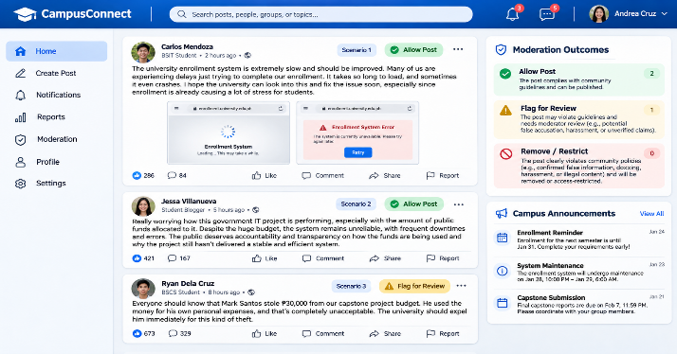
Screen 2: Create a Post | 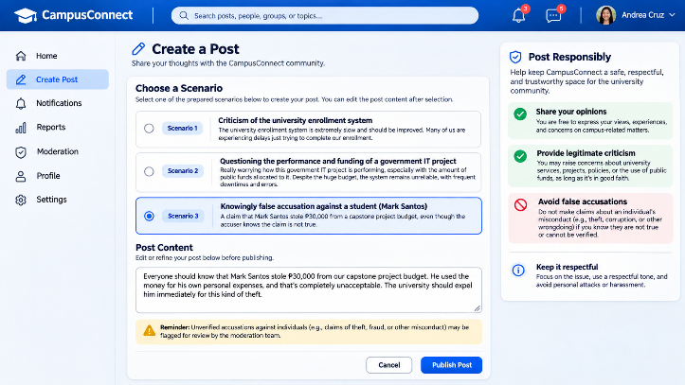
Screen 3: Content Warning | 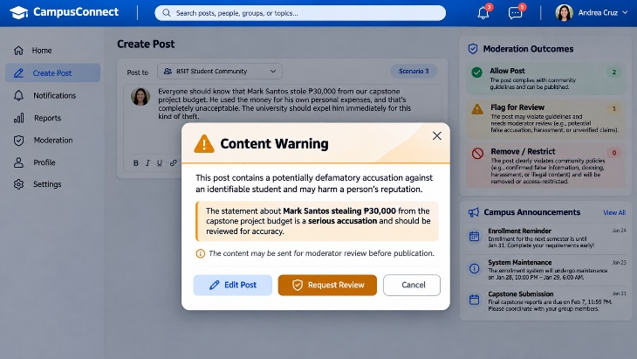
Screen 4: Content Moderation Dashboard | 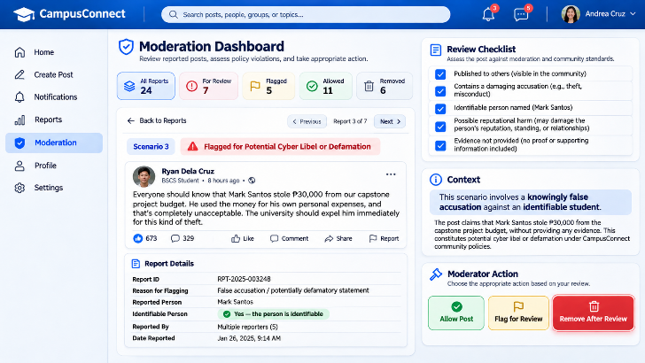
Screen 5: Moderation Decision and Appeal | 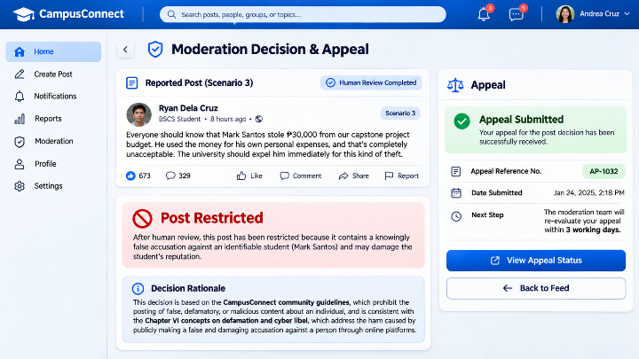

  - Scenario Analysis/Rationale – (A brief analysis of the three selected scenarios and corresponding moderation decisions.)
Example:
Our group designed CampusConnect to demonstrate responsible content moderation based on Chapter VI: The Blogger's Freedom of Expression and the Cyber Libel Law.
For Scenario 1, the platform allows the student's criticism of the enrollment system because it discusses an actual service concern and does not establish a defamatory accusation against an identifiable person.
For Scenario 2, the platform allows the post questioning the performance and funding of a government IT project. Public discussion and criticism of government services support freedom of expression and public accountability.
For Scenario 3, the platform displays a content warning because the statement contains a knowingly false accusation against an identifiable student and may damage the student's reputation. The content is referred for human review before a restriction is imposed.
Our design includes human moderation and an appeal process to prevent unnecessary censorship. We believe content moderation should examine the facts and context of each case rather than automatically remove posts simply because they express negative opinions.
Through this prototype, our group demonstrates how IT professionals can design digital systems that promote responsible online communication while respecting freedom of expression.

  - User Flowchart – (A diagram showing how posts are submitted, reviewed, and moderated.)
Example:
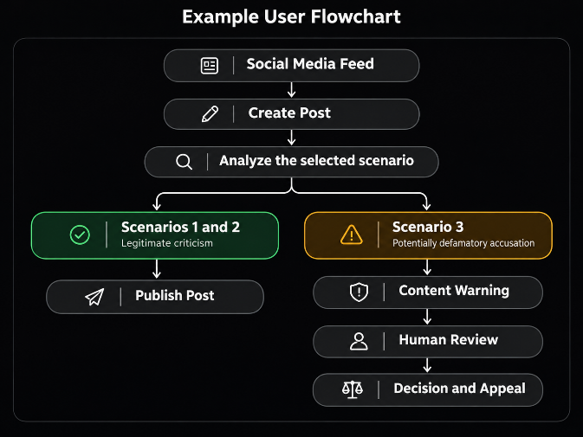

Groupings:
Group | Members
BSIT 4A
1 | ABELLANOSA, Leo Mark S. | COMAJIG, Deanne Marie F. | NABONG, Jericho C.
2 | ALMOROTO, Ulysses Joi T. | DACAYMAT, Einstien F. | OMICTIN, Rashel B.
3 | AMANTE, Grifaith S. | DEGRACIA, Renato S. Jr. | PAILAGAO, Kyle Andrew C.
4 | BAGONGON, Angelica G. | FORMENTERA, Joshua Dave T. | PLANOS, Karl Justin A.
5 | BAGUINANG, Lenie L. | GAVIOLA, Emmanuelle Braindale C. | POSADAS, Michaia El N.
6 | BAJAO, Christian S. | GUARDIARIO, Diane Angel B. | RAGPALA, Jessa Mia B.
7 | BALAGOT, Maria Suzette I. | LIG-ANG, Salm Virnel B. | SALVO, Feb Josh M.
8 | CAMANCE, Paul Dwight E. | MACAYANGA, Justine A. | TION, Jhyvriel Ian C.
9 | CAPILI, Renier Jake C. | MENIANO, Cyrus Jasper V. | UBAUB, Edilmar B.
BSIT 4B
1 | ALMONIA, Sharanie B. | DAMALAN, Kier Wowie L. | LIM, Sandarah C. | PINOTE, Jony C.
2 | BAGUIO, Jamaica P. | GALANQUE, Jean Era L. | LOPEZ, Rodulfo Daniel R. | PULMANO, Jr., Benjie A.
3 | BAQUERO, Riza Mae M. | GERONA, Prince Kenneth Basselle | MEDINA, Micko Andrei M. | ROMERO, Shejarra S.
4 | COQUILLA, Eliezer C. | GUIBONE, Lady Jean F. | PAMISA, Agnes G. | SABUERO, Kerah R.
5 | DAGASUHAN, Jedia Nicole L. | LABOSTRO, Levy Jean M. | PARCON, Jomel T. | SALVALEON, Jed P.
6 | DAGONIO, Anthony T. | LIDASAN, Jhaber M. | PECATO, Kennith James G. | WASIL, Franny Faith F.
BSIT 4C
1 | 1. ABRAZADO, Vanessa Caroline P. 2. BORRES, Emeliza A. 3. LAMO, Julfelyn L. 4. PADERAN, Jeraldine F. 5. TRUYA, Christian Daniel
2 | 1. ACIERTO, Sebastian Anthony G. 2. CAMBARIJAN, Rhea Mae B. 3. LLAMERA, Zyryll Ghuin L. 4. PARINASAN, Eva Mae C.
3 | 1. AGUSAN, Joshua B. 2. CAÑAS, Ernie Keith L. 3. LLAMO, Anthony G. 4. PAYLANGCO, Michelle M.
4 | 1. ALASAN, Julianna Joyce 2. CLEMEN, Tristan Amiel A. 3. MACARAYAN, Penelope E. 4. PECHARES, Joselito S. Jr.
5 | 1. ALMOROTO, Peter Christian T. 2. DOMO, Mary Rose A. 3. MANDAMIENTO, Javenn L. 4. RAMAO, Jolina C.
6 | 1. AMPER, Jasper P. 2. ELAY, Judy Amor O. 3. MAPANO, Jelleah Rozette Z. 4. RAUTRAUT, Jhon Lloyd L.
7 | 1. ARRUBIO, Milwaukee D. 2. FERMO, Lance Andre G. 3. MIRANDA, Michelle Van P. 4. SAPORCO, Michael R.
8 | 1. AUDITOR, Edzel Rey V. 2. GABUCAN, Maria Isabelle A. 3. NARVASA, Christyl Joy S. 4. SICALAG, Mark Tristan A.
9 | 1. BENICO, Jennefer Diane S. 2. GALORPOT, Vec Arvell D. 3. OCERO, Jr., Floro C. 4. SIHAY, Rex Dominic B.
10 | 1. BINONSAD, Jackylou A. 2. LAGARE, Lianne 3. OYAY, James A. 4. SITOY, Princess Grace Marie Z.

